**Hadoop Virtual Machine**

**Installation Instructions**

**USING VIRTUAL BOX**

To avoid all the bells and whistles of a full Hadoop installation we will use some out-of-the-box Virtual Machines that have all the prerequisites pre-installed, in that case all you have to do is download and install them so that we can run our examples live during the lecture.

**Install a virtualization software to run the virtual machines**

There are many choices availabe, with the most popular ones being VirtualBox (free) and Vmware. I recommend VirtualBox .

Here is how you can install it on your machine.

1. Go to VirtualBox download page <https://www.virtualbox.org/wiki/Downloads>

2. Download the package that suites your platform. My guess is that most of you have Windows machines so from the bullets choose “VirtualBox 4.3.6 for Windows hosts”. In any other case choose the appropriate package.

3. Download and install “VirtualBox 4.3.6 Oracle VM VirtualBox Extension Pack” from the same page above.

You may find detailed installation instructions with screen-shots in the manual pages.

• Brief installation instructions:

<https://www.virtualbox.org/manual/ch01.html#intro-installing>

• More details:

<https://www.virtualbox.org/manual/ch02.html>

**Installing on Windows hosts**

### Prerequisites

For the various versions of Windows that we support as host operating systems, please refer to below:-

* + Windows XP, all service packs (32-bit)
  + Windows Server 2003 (32-bit)
  + Windows Vista (32-bit and 64-bit[[1](https://www.virtualbox.org/manual/ch01.html" \l "ftn.idp91952496)]).
  + Windows Server 2008 (32-bit and 64-bit)
  + Windows 7 (32-bit and 64-bit)
  + Windows 8 (32-bit and 64-bit)
  + Windows Server 2012 (64-bit)

In addition, Windows Installer 1.1 or higher must be present on your system. This should be the case if you have all recent Windows updates installed.

### Performing the installation

The VirtualBox installation can be started

* either by double-clicking on its executable file (contains both 32- and 64-bit architectures)
* or by entering

VirtualBox.exe -extract

on the command line. This will extract both installers into a temporary directory in which you'll then find the usual .MSI files. Then you can do a

msiexec /i VirtualBox-<version>-MultiArch_<x86|amd64>.msi

to perform the installation.

In either case, this will display the installation welcome dialog and allow you to choose where to install VirtualBox to and which components to install. In addition to the VirtualBox application, the following components are available:

USB support

This package contains special drivers for your Windows host that VirtualBox requires to fully support USB devices inside your virtual machines.

Networking

This package contains extra networking drivers for your Windows host that VirtualBox needs to support Bridged Networking (to make your VM's virtual network cards accessible from other machines on your physical network).

Python Support

This package contains Python scripting support for the VirtualBox API (see [Chapter 11, *VirtualBox programming interfaces*](https://www.virtualbox.org/manual/ch11.html)). For this to work, an already working Windows Python installation on the system is required.[[8](https://www.virtualbox.org/manual/ch02.html" \l "ftn.idp95547216)]

Depending on your Windows configuration, you may see warnings about "unsigned drivers" or similar. Please select "Continue" on these warnings as otherwise VirtualBox might not function correctly after installation.

The installer will create a "VirtualBox" group in the Windows "Start" menu which allows you to launch the application and access its documentation.

With standard settings, VirtualBox will be installed for all users on the local system. In case this is not wanted, you have to invoke the installer by first extracting it by using

VirtualBox.exe -extract

and then do as follows:

VirtualBox.exe -msiparams ALLUSERS=2

or

msiexec /i VirtualBox-<version>-MultiArch_<x86|amd64>.msi ALLUSERS=2

on the extracted .MSI files. This will install VirtualBox only for the current user.

If you do not want to install all features of VirtualBox, you can set the optional ADDLOCAL parameter to explicitly name the features to be installed. The following features are available:

VBoxApplication

Main binaries of VirtualBox.

### Note

This feature must not be absent since it contains the minimum set of files to have working VirtualBox installation.

VBoxUSB

USB support.

VBoxNetwork

All networking support; includes the VBoxNetworkFlt and VBoxNetworkAdp features (see below).

VBoxNetworkFlt

Bridged networking support.

VBoxNetworkAdp

Host-only networking support.

VBoxPython

Python support.

**Install Cloudera's Quickstart Virtual Machine**

We will also use Cloudera QuickStart VM Here is how you can download and install/import this VM in your machine using VirtualBox.

1. Go to Cloudera's Quickstart VM download page

<http://www.cloudera.com/content/cloudera/en/downloads.html> and download the appropriate file. Be sure to select “VirtualBox” version if you have VirtualBox installed.

1. After download has complete (Size: ~2GB. it may take some time based on your internet connection) extract the downloaded package. By now you must have a fille named “cloudera-quickstart-vm-4.4.0-1-virtualbox.ovf”
2. Open VirtualBox from your start menu
3. From VirtualBox select File>Import Appliance
4. Navigate to your “cloudera-quickstart-vm-4.4.0-1-virtualbox.ovf” file and click “Next”.
5. Using the default options click import and your VM will start being imported.
6. When import is finished you will normally be able to start your Quickstart VM from the VirtualBox menu.

**USING VIRTUAL MACHINE**

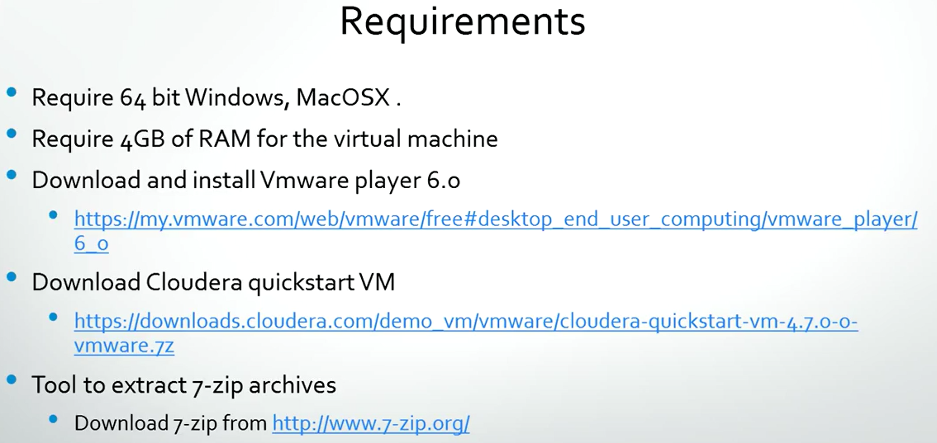

Download and Extract cloudera-quickstart vm

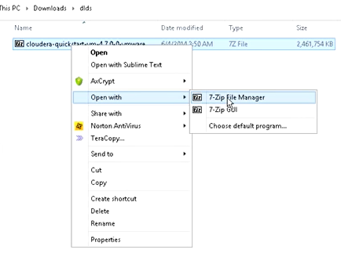

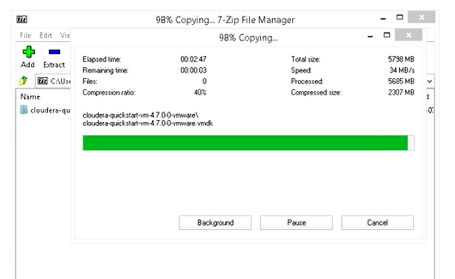

Different files extracted

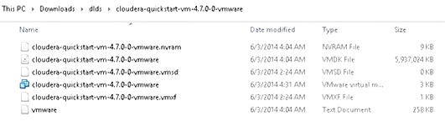

Use the highlighted file

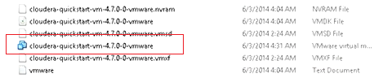

Already downloaded and Installed Vmware player

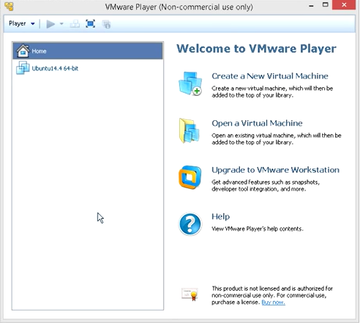

Now you have two different options:-

1. Create a new virtual machine
2. Open a virtual machine

Since now you are having a Virtual Machine as cloudera quickstart vm. So just click on Open a virtual machine and direct it to a folder where you have kept you cloudera quickstart VM.

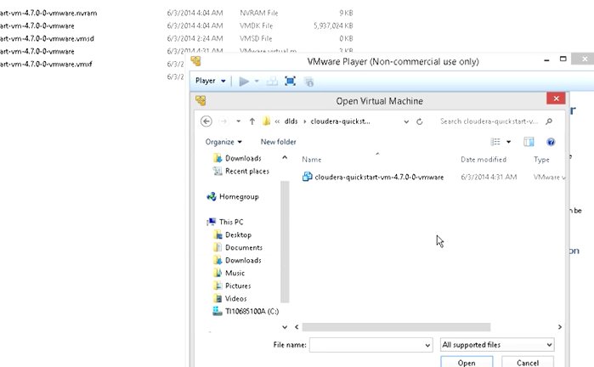

Select this and open

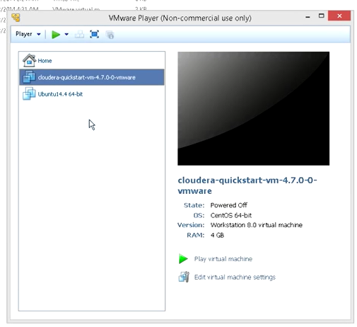

Now change the concerned settings

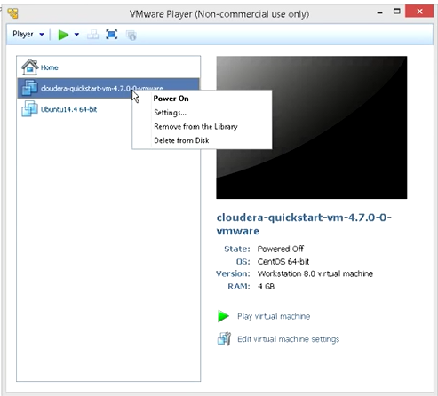

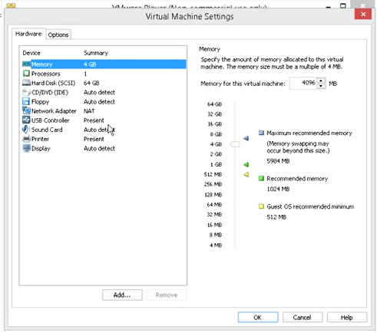

You can grant processors

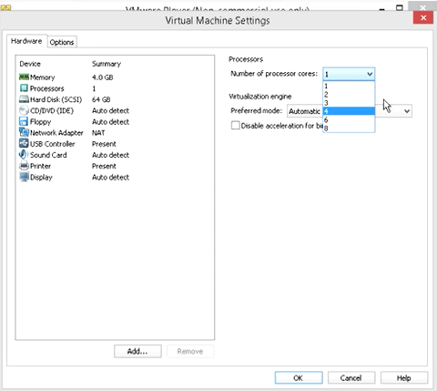

And disk

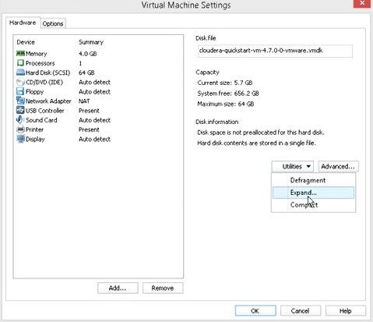

You also have an option to add different hardwares

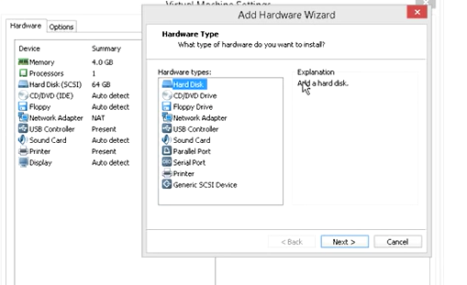

You can also change the name of your virtual machine

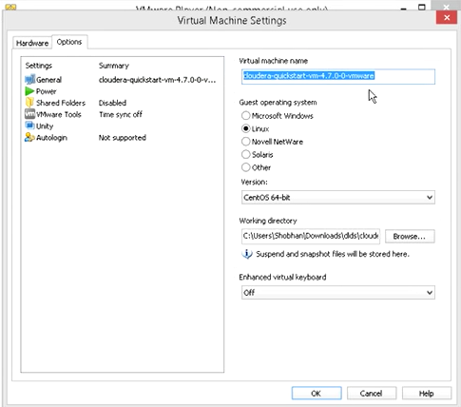

Select the virtual machine and click on Start

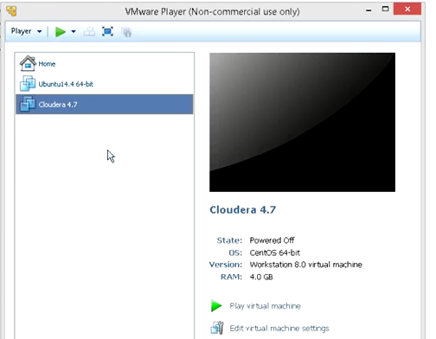

Your machine will start

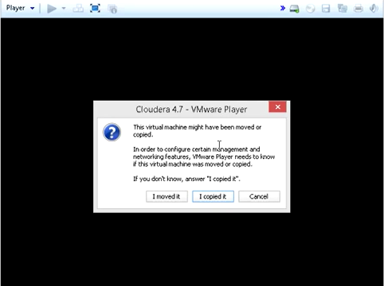

This is starting

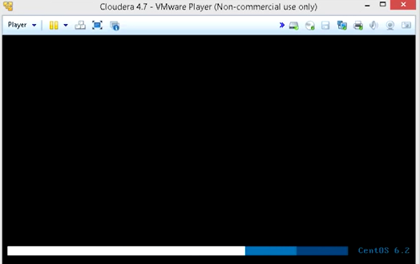

Desktop of cloudera

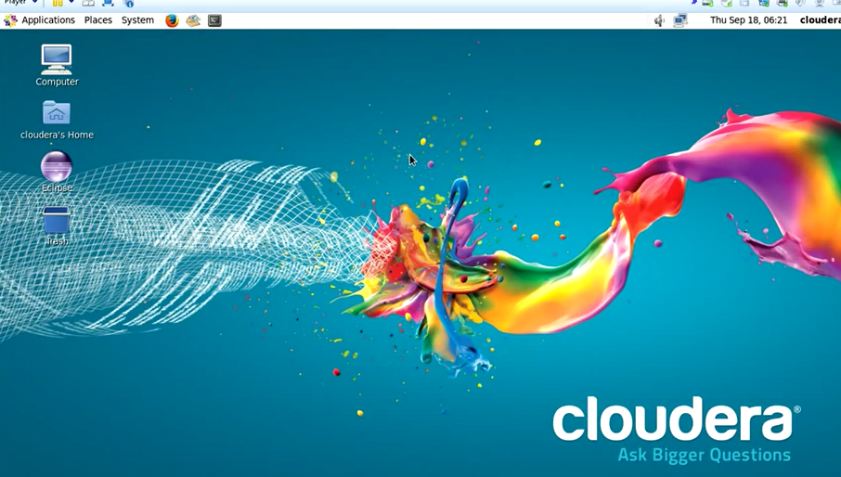

By default it will start firefox and there you will find cloudera manager and hue link

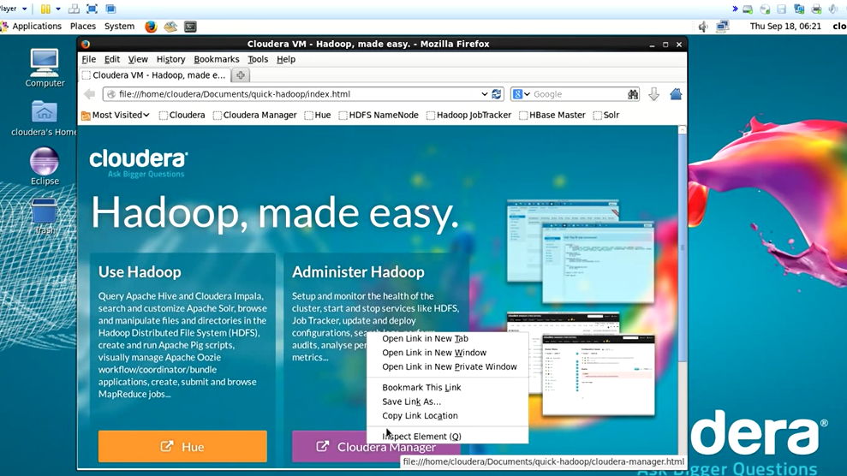

This time username and password for Cloudera Manager and Hue is **cloudera / cloudera**

